Child on Child abuse Policy

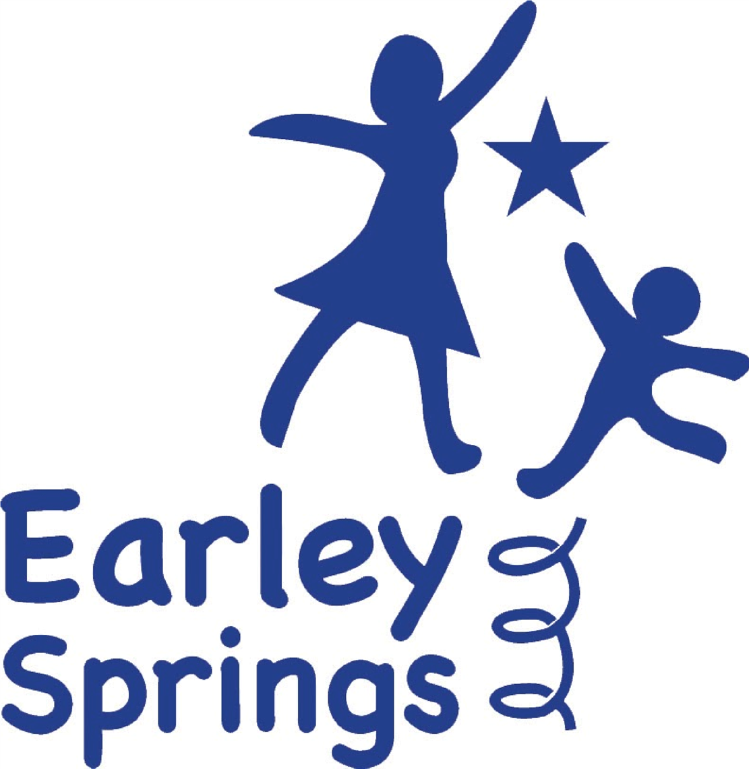

Written by | Harriet Carter | September 2026
Next review due by |  | September 2027

This policy has been developed in accordance with Keeping Children Safe in Education 2026, Working Together to Safeguard Children 2026, the Children Acts 1989 and 2004, the Education Act 2002, the Equality Act 2010, the Human Rights Act 1998, the SEND Code of Practice and the Education (Independent School Standards) Regulations 2014. Earley Springs also follows the safeguarding arrangements, procedures and thresholds established by the Kent Safeguarding Children Multi-Agency Partnership (KSCMP).
Earley Springs recognises that child-on-child abuse is a safeguarding issue and should never be dismissed as normal childhood behaviour, banter, conflict, experimentation or part of growing up.
This policy reflects the expectation that schools maintain a whole-school culture of vigilance, prevention and early intervention. All safeguarding decisions will place the wishes, feelings and best interests of the child at the centre of practice.
This policy should be read alongside the Safeguarding and Child Protection Policy, Behaviour Policy, Anti-Bullying Policy, Acceptable Use Policy, Mobile and Smart Technology Policy, Staff Code of Conduct, Sexual Violence and Sexual Harassment Policy and Relationships, Sex and Health Education Policy.
Earley Springs will never tolerate, normalise or minimise child-on-child abuse. Abuse of any kind will never be dismissed as “banter”, “just having a laugh”, “part of growing up” or “boys being boys”. All concerns will be taken seriously and considered through a safeguarding lens. Responses will be child-centred, proportionate and informed by the individual needs, communication profile and developmental understanding of the children involved. Where appropriate, concerns will be escalated to external safeguarding agencies.
Child-on-child abuse is abuse of a child by another child or children. It can occur between children of any age or sex, individually or as part of a group, inside or outside school and online. A child's developmental level, SEND, communication needs or understanding may be relevant to how the school responds, but these factors do not remove the need to recognise, assess and respond to harm. All staff should be aware of safeguarding issues around child on child abuse including:
- Bullying (including cyberbullying, prejudice-based and discriminatory bullying)
- Abuse in intimate personal relationships between children (sometimes known as ‘teenage relationship abuse’)
- Gender-based violence
- Physical abuse such as hitting, kicking, shaking, biting, hair pulling, or otherwise causing physical harm (this may include an online element which facilitates, threatens and/or encourages physical abuse)
- Sexual violence, such as rape, assault by penetration and sexual assault; (this may include an online element which facilitates, threatens and/or encourages sexual violence)
- Sexual harassment, such as sexual comments, remarks, jokes and online sexual harassment, which may be stand-alone or part of a broader pattern of abuse causing someone to engage in sexual activity without consent, such as forcing someone to strip, touch themselves sexually, or to engage in sexual activity with a third party
- Consensual and non-consensual sharing of nude and semi-nude images and/or videos (also known as sexting or youth produced sexual imagery)
- Up-skirting, which typically involves taking a picture under a person’s clothing without their permission, with the intention of viewing their genitals or buttocks to obtain sexual gratification, or cause the victim humiliation, distress, or alarm,
- Initiation/hazing type violence and rituals (this could include activities involving harassment, abuse or humiliation used as a way of initiating a person into a group and may also include an online element).
- Child-on-child abuse may also involve coercive or controlling behaviour, exploitation, prejudice-based abuse, abuse facilitated through technology and harmful behaviour occurring within intimate relationships between children. Several forms of harm may occur simultaneously and behaviour may move between the online and offline environment.
All staff should be clear as to the policy and procedures with regards to child on child abuse. All staff receive at least annual training on how to address concerns of this nature.
This abuse can:
- Be motivated by perceived differences e.g. on grounds of race, religion, gender, sexual orientation, disability or other differences
- Result in significant and potentially long-lasting physical, emotional, psychological, social or educational harm to the child experiencing the abuse.
Earley Springs recognises that a child who displays harmful behaviour may themselves have experienced abuse, trauma, exploitation, unmet need or other adversity. The school will therefore safeguard and support all children involved while remaining clear that the impact of harmful behaviour on another child must never be minimised. Understanding the reasons for behaviour does not remove the need to protect other children from harm.
At Earley Springs, communication differences must never become a barrier to safeguarding. Staff will presume competence and recognise that a child may communicate distress, discomfort, fear or disclosure through speech, behaviour, AAC, spelling, gesture, body language, changes in regulation or other individual methods of communication. Staff must not assume that behaviour indicating possible harm is simply a feature of a child's SEND without further exploration.
Responsibility:
The Proprietor retains ultimate responsibility for ensuring that Earley Springs meets its safeguarding duties and the Independent School Standards. The Headteacher is responsible for ensuring that effective child-on-child abuse procedures are implemented operationally. The DSL leads the safeguarding response to concerns and the Executive Board provides independent strategic scrutiny, challenge and assurance.
- All staff are aware that children can abuse other children (often referred to as child-on-child abuse) and that it can occur both within and outside of school, including online.
- All staff are clear on Earley Springs’ policies and procedures regarding child-on-child abuse and understand their crucial role in preventing it and responding appropriately when they suspect a child may be at risk.
- Staff acknowledge that the absence of reported incidents does not necessarily mean child-on-child abuse is not happening. It may simply be underreported. Therefore, it's vital that staff who have any concerns regarding child-on-child abuse speak to the designated safeguarding lead (or deputy).
- All staff recognise the importance of challenging inappropriate behaviors between children, many of which are listed below, as these behaviors can be abusive in nature. Minimising the severity of certain behaviors, such as dismissing sexual harassment as "just banter," "just having a laugh," "part of growing up," or "boys being boys," can create a culture that normalises abuse, leading children to accept it as acceptable and refrain from reporting it.
KCSIE also emphasises the importance of the child's voice:
The child's wishes and feelings will be considered when determining what action to take and what support to provide. Earley Springs will ensure that pupils have accessible and appropriate ways to express their views, communicate concerns and provide feedback. The child's best interests will remain central to safeguarding decision-making.
Earley Springs recognises that reporting does not have to be verbal. Pupils will be supported to communicate concerns through their established and preferred communication methods, including speech, gesture, visuals, AAC, spelling, body language, behaviour or other individual communication systems. Staff will remain professionally curious where a pupil's behaviour, regulation, engagement or communication changes and will not wait for a verbal disclosure before acting on a concern.
Purpose of Policy:
The primary objective of this policy is to safeguard children from child-on-child abuse. This document forms part of the Earley Springs Child Protection and Safeguarding Policy and must always be read alongside it. All procedures within this policy follow the expectations in Keeping Children Safe in Education and Working Together to Safeguard Children. It outlines a proactive and supportive approach to addressing such issues.
This policy should be read in conjunction with the following Earley Springs policies:
- Anti-Bullying Policy
- Safeguarding Policy
- Online Safety Policy
- Health and Safety Policy
- Behaviour Policy
- Mobile Technology and Social Media Policy
- Sexual Violence and Harassment Policy
- Relationships, Sex, and Health Education Policy
Framework and Legislation:
This policy is underpinned by the core principles of the Children's Act 1989, which prioritises the child's welfare. The guidance in "Working Together to Safeguard Children" emphasises that every child assessment must consider the child's perspective and recognise individual resilience when planning appropriate support. This principle is echoed in Keeping Children Safe in Education, which stresses the importance of incorporating the child's voice in school procedures.
Roles and responsibilities
Safeguarding is everyone’s responsibility at Earley Springs.
The Proprietor retains ultimate responsibility for ensuring compliance with the Independent School Standards and for ensuring that effective arrangements are in place to safeguard and promote the welfare of pupils.
The Headteacher retains overall operational responsibility for ensuring that effective safeguarding arrangements are in place and that child-on-child abuse concerns are responded to promptly, proportionately and in line with statutory guidance.
The Designated Safeguarding Lead and Deputy Designated Safeguarding Leads are responsible for receiving concerns, coordinating safeguarding responses, making referrals where required, maintaining accurate records and supporting staff in decision making.
All staff are responsible for maintaining professional curiosity, recognising indicators of child-on-child abuse and reporting concerns immediately in accordance with safeguarding procedures. Staff must never investigate concerns independently or seek to resolve safeguarding concerns without DSL oversight.
The Executive Board provides strategic oversight and assurance that safeguarding arrangements remain effective and compliant with Independent School Standards requirements.
Expected Staff Action:
Any concern, disclosure, allegation or observed incident of child-on-child abuse must be reported immediately to the Designated Safeguarding Lead or Deputy DSL.
Staff should respond calmly, reassure the child that they have been heard and explain that information will only be shared with those who need to know in order to keep them safe.
Staff must not promise confidentiality, conduct interviews, ask leading questions or investigate concerns themselves.
All safeguarding concerns, actions and outcomes will be recorded on Bromcom in accordance with safeguarding procedures and record keeping requirements.
The school recognises that disclosures may not always be verbal and that behavioural change, withdrawal, dysregulation, communication differences or emotional presentation may indicate safeguarding concerns.
Taking Action:
All reports of child-on-child abuse will be taken seriously and considered on a case-by-case basis.
The immediate priority will always be the safety, protection and wellbeing of all children involved.
The DSL will consider the wishes and feelings of the child experiencing harm, the nature and seriousness of the alleged behaviour, the ages and developmental understanding of the children involved, any power imbalance, SEND or communication needs, whether the behaviour may constitute a criminal offence, whether there is a risk of further harm and whether other children may also be at risk.
Where allegations indicate that a criminal offence may have occurred, Earley Springs will follow statutory safeguarding procedures and seek advice before undertaking any internal investigation.
Support planning will consider the needs of the child experiencing harm, the child displaying harmful behaviour and the wider school community.
Risk assessments, supervision arrangements, environmental adaptations, timetable changes and additional safeguarding measures may be implemented where necessary.
Decisions and outcomes will be recorded and reviewed regularly.

Sexual Violence and Sexual Harassment
All reports of sexual violence and sexual harassment will be taken seriously and managed as safeguarding concerns. The school will not wait for a child to make a formal disclosure before acting where staff have reason to believe that harm may have occurred.
The DSL will undertake an immediate risk and needs assessment considering the child experiencing harm, the child alleged to have caused harm and any other children who may be at risk. Appropriate safeguarding arrangements will be implemented without delay.
Where a report may involve a criminal offence, the DSL will consider referral to children's social care and/or the police in accordance with KCSIE 2026 and local safeguarding procedures. The school will liaise with external agencies before undertaking action that could prejudice a criminal investigation.
Where possible, the child experiencing harm and the child alleged to have caused harm will be kept apart while safeguarding assessments are undertaken. Any arrangements will be proportionate and will seek to avoid placing an unreasonable burden on the child who has experienced harm.
Support will be provided to all children involved according to their individual needs. Any disciplinary response will be considered separately from the safeguarding response and in accordance with the Behaviour Policy.

Sharing Nudes and Semi-Nudes
Any incident involving the consensual or non-consensual sharing of nude or semi-nude images or videos involving children must be reported immediately to the DSL. Staff must not view, copy, print, share, store or save the imagery, ask a child to send or download it, or investigate the incident themselves.
The DSL will respond in accordance with current UK Council for Internet Safety guidance and KCSIE 2026, including considering whether referral to children's social care and/or the police is required. All decisions, actions and rationale will be recorded on Bromcom.

Ongoing Support and Review
Support following child-on-child abuse will not end when the immediate incident has been addressed. The DSL will ensure that safeguarding arrangements and support plans are reviewed for as long as necessary.
Support will be individualised and may include pastoral support, communication support, environmental adaptations, supervision arrangements, therapeutic input, curriculum support and involvement from external professionals.
The school will consider the ongoing needs of the child who has experienced harm, the child who has displayed harmful behaviour and any other children affected by or witnessing the incident. Parents and carers will normally be involved unless doing so would place a child at increased risk of harm.
Where appropriate, the school will consider whether an incident indicates a wider safeguarding, cultural, environmental or systemic issue requiring changes to practice, supervision, curriculum or the school environment.
Preventative Strategies:
Earley Springs promotes a culture of safety, respect and positive relationships through curriculum delivery, communication support, environmental design and proactive safeguarding practice.
Preventative work is embedded through PSHE, Relationships and Health Education, online safety education, pupil voice opportunities and development of communication and self-advocacy skills.
The school recognises that pupils with SEND and communication differences may require explicit teaching, adapted resources and supported opportunities to understand consent, boundaries, privacy, healthy relationships and personal safety.
Staff receive regular safeguarding training and are expected to challenge language, behaviours and attitudes that could contribute to unsafe cultures.
Pupils are supported to understand how to seek help, report concerns and identify trusted adults within school.
Earley Springs recognises that prevention must be accessible to the individual pupil. Teaching about consent, relationships, boundaries, privacy, online safety and reporting concerns will therefore be differentiated and reinforced using communication approaches appropriate to each child's needs.
The school will monitor patterns and trends in child-on-child abuse, bullying, sexualised behaviour and safeguarding concerns. This will include consideration of locations, times, peer groups and online environments where concerns arise. Findings will be used to inform risk assessment, curriculum planning, staffing, environmental arrangements and safeguarding practice.
References:
Keeping Children Safe in Education 2026 – Department for Education
Working Together to Safeguard Children 2026 – Department for Education
Education (Independent School Standards) Regulations 2014
Preventing and Tackling Bullying – Department for Education
Sharing Nudes and Semi-Nudes: Advice for Education Settings – UK Council for Internet Safety
Kent Safeguarding Children Multi-Agency Partnership safeguarding procedures and Safeguarding in Education guidance

