Assessment Policy

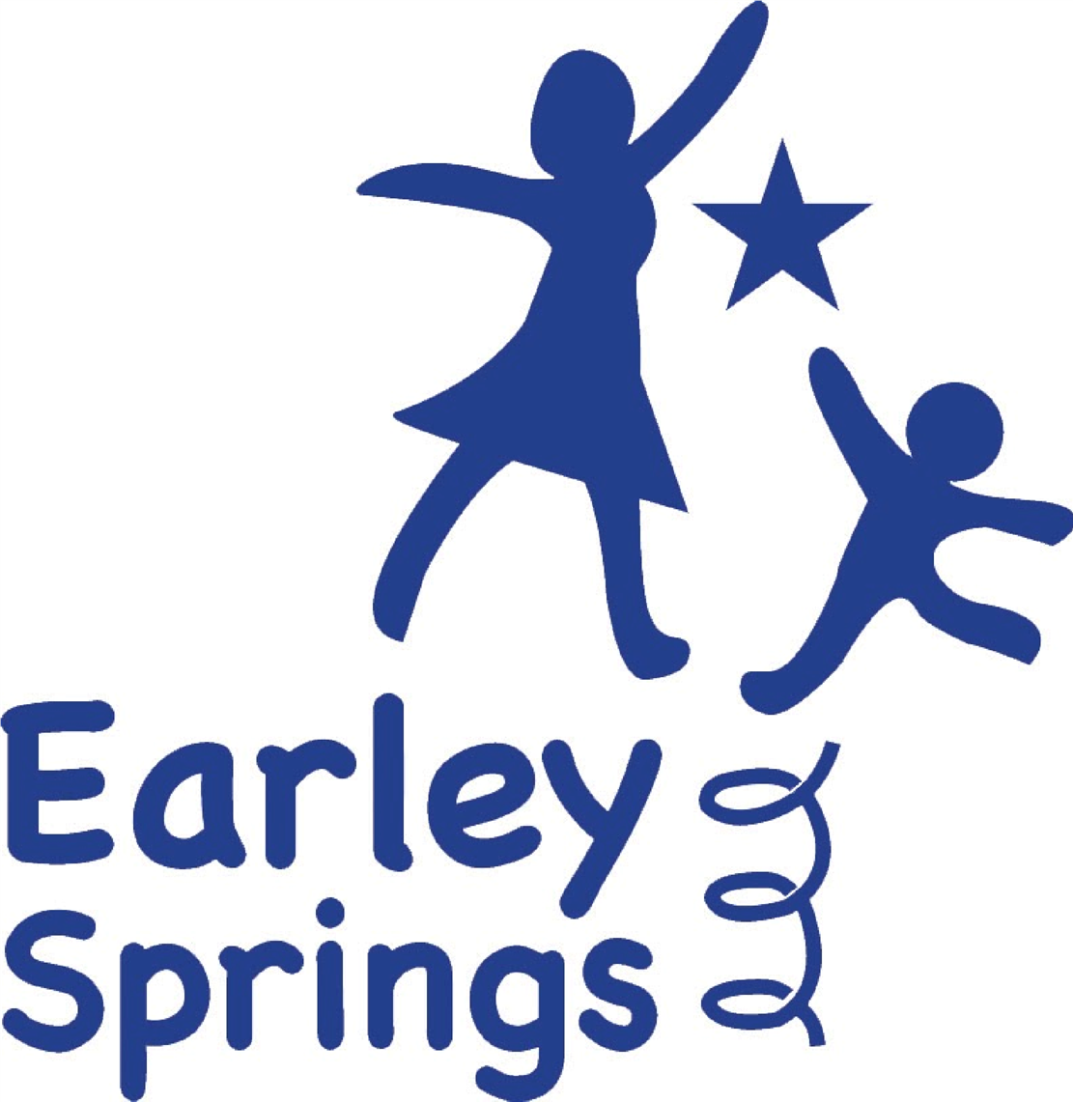

Written by | Harriet Carter | September 2026
Next review due by |  | September 2027

Statutory and Regulatory Framework
This policy has been developed with regard to the Education (Independent School Standards) Regulations 2014, the children and Families Act 2014, the SEND Code of Practice: 0–25 years (2015), the Equality Act 2010, the Education Act 2002, the EYFS Statutory Framework (2024), Development Matters (2023), the Engagement Model, Keeping children Safe in Education (current edition), the Data Protection Act 2018, UK GDPR and relevant Department for Education guidance relating to assessment.

Purpose
The purpose of assessment at Earley Springs is to identify each pupil's starting point, monitor progress, inform teaching, celebrate achievement, identify barriers to learning, evaluate curriculum effectiveness and ensure every pupil receives ambitious, personalised learning that enables them to achieve their individual potential.
Underpinning Principles for Assessment
At Earley Springs we recognise that progress for pupils with SEND is rarely linear. Many pupils make significant progress through small, cumulative developmental steps which may not always be reflected through age-related expectations or standardised assessment measures. Our assessment systems are therefore designed to recognise, celebrate and record meaningful progress in learning, communication, independence, regulation and Preparation for Adulthood.
Assessment is fundamental to the teaching and learning process at Earley Springs. It provides the evidence that guides our teaching and allows pupils to demonstrate and review their own progress. We believe that assessment should be fair, inclusive of all abilities, and free from any bias that is not relevant to what is being assessed. Honesty in assessment is paramount. This means that assessment outcomes are used in ways that support learning and minimize any negative consequences. We are open and transparent in how we convey assessment results to pupils, and our experienced staff moderate judgements to ensure accuracy.
We strive for ambition in our assessment practices. This means setting high expectations for our pupils and placing their achievements in context using developmentally appropriate benchmarks and individual starting points. Through objective criteria, assessment embodies a clear pathway of progress and development for every pupil.
All assessment practices should be appropriate to the age and stage of the pupil, as well as the specific task and the type of feedback desired. We believe in using a wide range of evidence to gain a complete picture of pupil achievement, while keeping our procedures and record-keeping efficient and focused on planning for future learning.
Consistency in assessment is also key. This ensures that judgements are made according to common principles, that results are easily understood by all stakeholders, and that our assessment information is clear, consistent and meaningful for all stakeholders
Meaningful assessment outcomes provide valuable information for everyone involved in the educational process. Pupils use this information to develop their learning, parents use it to support their pupils, and teachers use it to plan and improve their teaching. Assessment data also informs decision-making for appropriate agencies, local authorities, school leaders, and governing bodies, as well as government bodies.
Finally, we believe that assessment feedback should inspire greater effort in our pupils and foster a belief that they can achieve more through hard work and practice.
Our Philosophy of Assessment
At Earley Springs, assessment is an integral part of high-quality teaching and learning. It helps us ensure that our teaching is effective and that pupils are making the expected progress. All staff members receive regular training in our assessment approach, and we have a senior leader, currently the headteacher, who oversees assessment practices.
The main purpose of assessment at Earley Springs is to provide information that helps teachers, parents, and pupils plan their next steps in learning. We also use assessment outcomes to evaluate and enhance our teaching standards. By collaborating with other provisions and engaging in external moderation where appropriate, we ensure that our assessment judgements are accurate, consistent and professionally validated.

Assessment of Communication
Communication is assessed across all curriculum pathways. Staff recognise that pupils may communicate through speech, AAC, signing, gesture, symbols, behaviour, facial expression, eye gaze, objects of reference and other personalised communication systems.
Assessment considers both expressive and receptive communication and recognises that understanding may exceed spoken language. Communication development informs curriculum planning, EHCP outcomes, Preparation for Adulthood and wider assessment across the curriculum.

EHCP Outcomes
Assessment is used to monitor progress towards EHCP outcomes throughout the year. Teachers review progress regularly and use assessment information to adapt provision, identify where additional intervention may be required and contribute to annual reviews.
Our Assessment System
Earley Springs uses B Squared to record both formative and summative assessment data. This holistic framework allows us to assess pupils across curriculum learning and functional life skills that will help them become better pupils and prepare them for their futures.
Our admissions procedures include an assessment period covering literacy, numeracy, reading, and speech and language. This helps us establish a baseline for each pupil and begin the process of developing a personalised curriculum.
B Squared provides a consistent assessment framework across the school and enables leaders to monitor individual progress, cohort trends, curriculum effectiveness and outcomes over time. Assessment information is used alongside professional judgement rather than in isolation.

Baseline Assessment
Prior to admission, and during each pupil's transition period, baseline information is gathered from parents, previous settings, EHCP documentation, professional reports and direct assessment. Baseline assessment information is reviewed by the class teacher and Senior Leadership Team to confirm the most appropriate curriculum pathway, identify any immediate support needs and establish individual learning priorities.
Baseline assessment includes:
- communication
- literacy
- numeracy
- cognition
- emotional regulation
- social interaction
- independence
- sensory processing
- physical development
- Preparation for Adulthood skills
Assessment Across Curriculum Pathways
Assessment at Earley Springs is structured around our three curriculum pathways: Explorers, Discoverers and Investigators.
- Explorers (Early Years & Engagement Model): Assessment is informed by the Statutory Framework for the Early Years Foundation Stage (2024) and Development Matters (2023), supported by the Engagement Model for pupils working below subject-specific learning. Observations, photos and evidence of play-based learning are captured through B Squared and Evisense to show progress across the prime and specific areas of learning. Assessment also considers Characteristics of Effective Learning, communication, regulation and independence.
- Discoverers: Assessment combines B Squared Connecting Steps with SCERTS and the Engagement Model to track social communication, emotional regulation and functional cognition. Assessment places particular emphasis on functional communication, emotional regulation, engagement, sensory needs and Preparation for Adulthood.
- Investigators: Assessment uses National Curriculum expectations as reference points only, where developmentally appropriate, to support ambition while remaining fully personalised. Assessment supports ambitious curriculum expectations whilst remaining personalised and recognising individual rates of development.
This structure ensures continuity of assessment and a clear progression pathway from Early Years through to Key Stage 3.

Preparation for Adulthood
Assessment includes Preparation for Adulthood outcomes including communication, independence, community participation, emotional wellbeing, self-advocacy, functional life skills and, where appropriate, early employability skills. These outcomes are assessed progressively throughout a pupil's time at Earley Springs and contribute to transition planning.
Our Approach to Different Forms of Assessment
Formative assessment is an ongoing process that happens during learning. It helps us assess pupils' knowledge, skills, and understanding; identify their strengths and any gaps in their learning; address misconceptions; and determine the next steps in their learning journey. Formative assessment also helps us diagnose the need for any extra support or intervention, and it informs teacher planning and reporting. We use a variety of formative assessment methods, including questioning, marking, observation, quizzes, reviewing pupil work, providing feedback, and encouraging self-assessment and reflection. Staff use retrieval practice, verbal feedback, structured questioning, observation, modelling, self-reflection, AAC responses, practical demonstrations and pupil discussion to establish understanding before adapting future teaching.
In-school summative assessment gives us a summary of what a pupil has learned over a period of time. These assessments, which are carried out at the end of each term, help teachers make informed judgements about pupil attainment and track progress within specific groups, classes, and across the whole provision. Summative assessments can take the form of written tests, observations, specific tasks, or photographs. We use B Squared to map pupil's progress against the developmental stage they are working within, using age-related expectations only as contextual reference points where appropriate, ensuring assessment remains meaningful and individualised. We also use some summative assessments as diagnostic tools to inform our ongoing teacher assessments. These include White Rose Maths assessments, Codebreakers Phonics assessments and extended writing tasks. Summative assessment is used to evaluate learning rather than simply generate data. Assessment information is proportionate and does not create unnecessary workload for staff.
While we prioritise pupil wellbeing and self-esteem alongside learning. Nationally standardised assessments are used where appropriate and where they provide meaningful information. For many pupils attending Earley Springs, personalised assessment provides a more accurate picture of progress than standardised measures alone. Instead, we focus on individual progress and utilise the Bsquared framework to assess pupils against the year band 'stage' they are working towards. Our teachers have high expectations and are knowledgeable about developmental progression and curriculum benchmarks, using these to inform ambitious yet appropriate targets.
For pupils within the Explorers pathway, assessment is rooted in the EYFS Statutory Framework (2024) and Development Matters (2023). Practitioners gather evidence through observation, play, and adult-led activities to identify progress across the seven areas of learning. Outcomes are moderated termly, recorded in B Squared, and inform transition planning into Key Stage 1. Pupils working below the expected level are assessed using the Engagement Model to capture meaningful small-step progress.

Moderation
Internal moderation takes place regularly across learning pathways to ensure assessment judgements remain accurate, reliable and consistent.
External moderation is undertaken where appropriate through local authority networks, professional partnerships and assessment providers. Moderation outcomes are used to strengthen professional judgement and improve consistency across the school.
Assessment judgements are triangulated using teacher observation, evidence recorded within Evisense, pupil work, practical demonstration, communication, discussion with support staff and professional judgement to ensure that no assessment decision is based upon a single piece of evidence.
Our Use of Assessment
We ensure our teachers stay up-to-date with the latest developments in assessment practice through regular staff meetings and professional development opportunities. Teachers use assessment data to analyse pupil attainment and progress, plan future learning, and identify any pupils who may need extra support. This information is shared with both parents and pupils, along with guidance on next steps. We celebrate all achievements across a broad and balanced curriculum, art, performance, behaviour, and social and emotional development. Assessment outcomes directly inform curriculum planning and delivery. Teachers use termly assessment analysis to adapt lesson content within each pathway, ensuring curriculum intent, implementation and impact are closely aligned.

Assessment for Pupils with Complex SEND
Assessment approaches are personalised for pupils with complex communication and interaction needs. Staff recognise that pupils may demonstrate learning through engagement, anticipation, initiation, regulation, interaction, problem solving, AAC, eye gaze, sensory responses and behaviour. Assessment does not rely solely upon written work or spoken responses.

Assessment of Personal Development
Assessment extends beyond academic achievement and includes communication, emotional wellbeing, resilience, independence, self-regulation, social interaction, behaviour for learning, physical development, Preparation for Adulthood, British Values and SMSC development.

Safeguarding and Assessment
Assessment information may contribute to safeguarding where changes in engagement, communication, attendance, behaviour, emotional presentation or learning indicate a potential welfare concern. Staff remain professionally curious and follow the Safeguarding and Child Protection Policy where assessment identifies possible safeguarding issues.

Leadership and Quality Assurance
The Headteacher has overall responsibility for assessment across the school. Senior leaders monitor assessment through moderation, pupil progress meetings, curriculum monitoring, learning walks, work scrutiny, assessment analysis and review of EHCP outcomes.
Leaders evaluate assessment information to ensure that pupils make ambitious progress, curriculum pathways remain appropriate and assessment systems continue to meet statutory requirements. Assessment information contributes directly to school improvement planning and quality assurance.
Roles and Responsibilities

Proprietor and Executive Board
The Proprietor and Executive Board are responsible for providing strategic oversight of assessment across Earley Springs. They ensure that appropriate assessment systems are in place to support high-quality teaching, monitor pupil progress and demonstrate compliance with the Education (Independent School Standards) Regulations 2014. They receive assurance that assessment is accurate, proportionate and used effectively to improve outcomes for pupils, whilst avoiding unnecessary workload for staff.
Headteacher
The Headteacher has overall responsibility for the implementation, quality assurance and strategic leadership of assessment across the school. This includes ensuring that assessment arrangements remain meaningful, reliable and proportionate; that staff receive appropriate professional development; that pupil progress is monitored through regular progress meetings; that assessment informs curriculum evaluation and EHCP reviews; and that moderation arrangements promote consistency and accuracy across all curriculum pathways.

Senior Leadership Team
The Senior Leadership Team is responsible for monitoring the quality and consistency of assessment practice throughout the school. Leaders evaluate assessment information alongside lesson observations, learning walks, work scrutiny, curriculum monitoring and pupil progress meetings to ensure that assessment accurately reflects pupils' learning and informs future teaching.
Senior leaders also ensure that assessment systems remain appropriate as the curriculum develops and that staff receive ongoing coaching and professional development where required.

Learning Approach Leads / Curriculum Leads
Learning Approach Leads monitor assessment within their curriculum pathways to ensure consistency, progression and appropriate challenge. They support teachers in interpreting assessment information, moderating judgements and adapting planning to meet pupils' individual needs. They also identify trends across cohorts and contribute to curriculum evaluation and improvement.

Teachers
Teachers are responsible for planning and carrying out accurate baseline, formative and summative assessment. They use assessment information to adapt teaching, monitor academic, communication and personal development, review progress towards EHCP outcomes, contribute to annual reviews and maintain accurate assessment records using agreed school systems. Teachers participate in moderation activities and communicate progress effectively with parents, carers and external professionals.

Teaching Assistants and Support Staff
Teaching assistants and support staff play an important role in gathering evidence of pupils' learning throughout the school day.
Under the direction of the class teacher they:
- contribute observations of learning and engagement;
- record evidence using agreed assessment systems, including Evisense;
- support assessment of communication, independence and Preparation for Adulthood skills;
- contribute to discussions regarding pupil progress;
- identify emerging strengths or concerns;
- support pupils to reflect upon and celebrate their own achievements.
Final assessment decisions remain the responsibility of the class teacher. Teaching assistants are not expected to make formal assessment judgements independently. Their observations form an important part of the evidence base that informs teacher assessment and professional discussion.

Pupils
Assessment at Earley Springs is centred on the individual pupil. Wherever possible, pupils are encouraged to participate in the assessment process by reflecting on their learning, celebrating achievements, expressing preferences, identifying next steps and contributing to their own EHCP outcomes.
Participation is personalised according to each pupil's communication profile and may include speech, signing, AAC, symbols, photographs, objects of reference, visual supports, choice making or other individual communication methods.

Assessment Cycle
Assessment at Earley Springs is continuous and forms part of everyday teaching. Formative assessment takes place during every lesson and informs immediate adaptations to teaching.
Formal summative assessment is completed termly using the school's agreed assessment systems. Progress is reviewed through pupil progress meetings, moderation activities and analysis by the Senior Leadership Team.
Assessment information contributes to annual reports, EHCP annual reviews, transition planning and school self-evaluation.

Parents and Carers
Parents and carers are valued partners in the assessment process. The school recognises that they hold important knowledge regarding their child's development, interests, communication and achievements outside school.
Parents and carers are encouraged to:
- contribute information during baseline assessment;
- attend review meetings and annual reviews;
- discuss progress with staff;
- share achievements from home;
- support agreed next steps in learning;
- work collaboratively with the school to ensure consistency between home and school.
Assessment information is shared regularly through reports, EHCP reviews, meetings and ongoing communication with families.

External Professionals
Where appropriate, assessment is informed by advice from external professionals including Educational Psychologists, Speech and Language Therapists, Occupational Therapists, Physiotherapists, specialist teachers and other professionals involved in a pupil's education or care.
Professional advice is used alongside teacher assessment to ensure that curriculum planning, intervention and provision remain appropriate to each pupil's individual needs.

Pupil Voice
Wherever possible, pupils contribute to the assessment process by sharing their views, celebrating achievements, identifying next steps and reflecting upon their own learning. Pupil voice may be gathered through speech, AAC, signing, symbols, observation, photographs, choice-making and other personalised communication methods appropriate to the individual.

Confidentiality and Data Protection
Assessment information is confidential and processed in accordance with the Data Protection Act 2018 and UK GDPR. Assessment records are stored securely within authorised school systems including B Squared and Evisense. Information is only shared with authorised professionals, parents, local authorities and other agencies where there is a lawful basis to do so.

Monitoring and Evaluation
This policy is monitored through moderation activities, assessment audits, work scrutiny, pupil progress meetings, curriculum monitoring, external moderation, parental feedback and review of assessment outcomes.
Findings inform staff training, curriculum development and the School Development Plan.

