Accessibility Plan



Written by | Harriet Carter | September 2026
Next review due by |  | Every 3 years

Accessibility Plan
At Earley Springs School, we are building a new, inclusive educational environment where all pupils, staff, parents, and visitors are valued. We are committed to removing barriers to access and learning by ensuring full compliance with the Equality Act 2010 and promoting a culture of inclusion and equity.
This Accessibility Plan is drawn up in line with Schedule 10 of the Equality Act 2010. The Proprietor retains overall responsibility for ensuring compliance with the Equality Act 2010 and Independent School Standards. Operational implementation and monitoring of this Accessibility Plan is delegated to the Headteacher, with strategic oversight provided through the Executive Board.

Legal Context
According to the Equality Act 2010, a person has a disability if they have a physical or mental impairment which has a substantial and long-term negative effect on their ability to do normal daily activities. Schools must make reasonable adjustments to avoid discrimination and to promote equal opportunities.
Independent School Standards Compliance
This Accessibility Plan supports compliance with:
• Part 3 – Welfare, Health and Safety of Pupils
• Part 5 – Premises and Accommodation
• Part 8 – Quality of Leadership and Management
Earley Springs recognises that accessibility extends beyond physical access and includes curriculum access, communication, participation, wellbeing and inclusion.

Objectives
Earley Springs School aims to:
-Increase access to the curriculum for pupils with disabilities or sensory impairments.
-Ensure the physical environment is accessible to all users.
-Improve the availability and delivery of written information in accessible formats.
As a special educational needs school, accessibility is embedded within all aspects of provision at Earley Springs School. All pupils have an Education, Health and Care Plan (EHCP) or equivalent assessed needs, and access to learning is planned on an individual basis. Reasonable adjustments are routinely made to ensure that pupils are not placed at a substantial disadvantage and are able to participate fully in school life.
Physical Environment
Earley Springs has been designed and adapted to promote accessibility across the school environment. The design and construction have incorporated the following features to ensure full access for individuals with disabilities:
- Ramp access from the car park to the school entrance.
- Ramp access within the school to provide level access to all internal areas.
- All external play areas are wheelchair accessible, with ramps connecting different levels.
- All toilets are fully accessible, including multiple disabled shower facilities.
The school also considers environmental accessibility through sensory-informed design, clear wayfinding, lighting, acoustics, access to regulation spaces, controlled access arrangements and the safe use of specialist environments to support participation and wellbeing.
Curriculum Access In a SEN Setting
Accessibility at Earley Springs extends beyond academic access and includes communication, sensory regulation, emotional wellbeing, social participation, independence and preparation for adulthood. Adaptations are planned proactively and reviewed regularly through assessment and EHCP processes.
Access to the curriculum at Earley Springs School is personalised and informed by each pupil’s EHCP outcomes and assessed needs. Teaching approaches, resources, timetabling, and learning environments are adapted to meet a wide range of cognitive, physical, sensory, emotional, and communication needs.
Specialist strategies and resources are used as appropriate, including visual supports, alternative and augmentative communication systems, sensory regulation strategies, assistive technology, and individualised learning programmes. Accessibility needs are reviewed through ongoing assessment, daily practice, and formal annual reviews, ensuring provision remains responsive as pupils develop.
Communication Accessibility
Earley Springs recognises communication as a core element of accessibility. The school provides a total communication environment and may utilise visual supports, AAC, Makaton, written supports, environmental communication systems and alternative methods of participation to reduce barriers and promote inclusion.

Accessibility of Written Information
We are committed to ensuring that written information provided to pupils, parents, and visitors is clear and accessible. Alternative formats such as large print, coloured paper, audio, and translated materials will be made available on request. We will also incorporate the use of visual aids and symbols to support understanding where appropriate.
Accessibility will be reviewed annually through environmental review, stakeholder feedback, pupil voice, admissions planning, incident analysis and curriculum evaluation to identify opportunities for further improvement.
3 Year Action plan

Objective | Action | Lead | Timescale | Success Criteria
Improve curriculum accessibility | Review adaptive teaching and communication supports | Headteacher | Annual | Pupils access curriculum
Improve physical accessibility | Audit site annually | Site Lead | Annual | Identified barriers reduced
Improve communication accessibility | Expand alternative formats | SLT | Ongoing | Information accessible
Improve environmental accessibility | Review sensory and regulation environments | SLT | Annual | Improved engagement

Monitoring and Review
The Proprietor and senior leadership team are responsible for ensuring that this Accessibility Plan is implemented effectively. Accessibility considerations are monitored through the school’s SEND systems, including EHCP reviews, pupil progress monitoring and regular review of the learning environment. Adjustments are made as required in response to changes in individual pupil needs or the school population.
This Accessibility Plan will be reviewed every three years, or more frequently if necessary. Accessibility considerations will be assessed on an ongoing basis, including dynamic assessments of new pupil needs. As the school grows and develops, we will ensure that accessibility remains integral to all decisions.
Accessibility considerations form part of admissions, transition and placement planning to ensure reasonable adjustments and support arrangements can be considered prior to admission wherever possible.

Plan
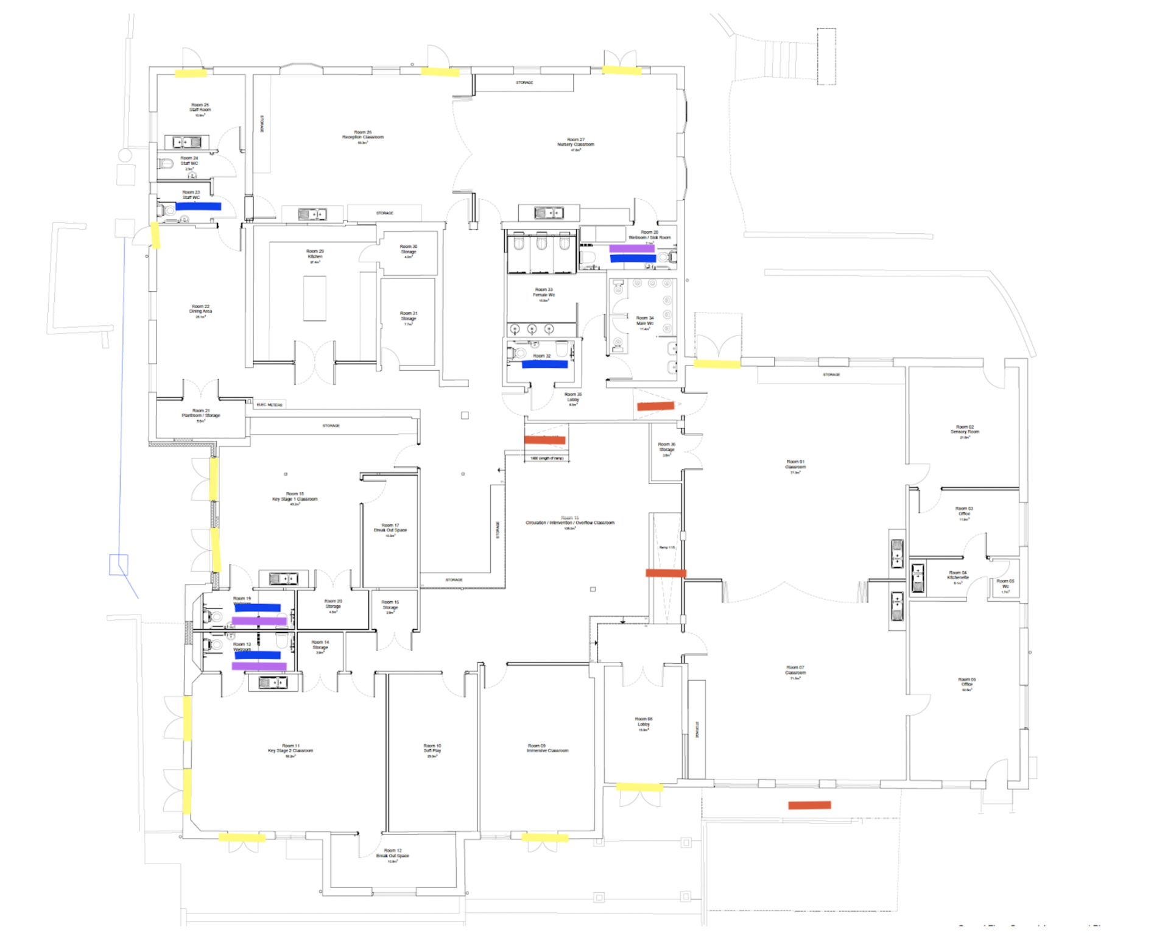

Yellow - External Accessible doors
Red - Accessible Ramps
Blue - Accessible Toilet
Purple - Accessible Shower

