Safer Recruitment Policy
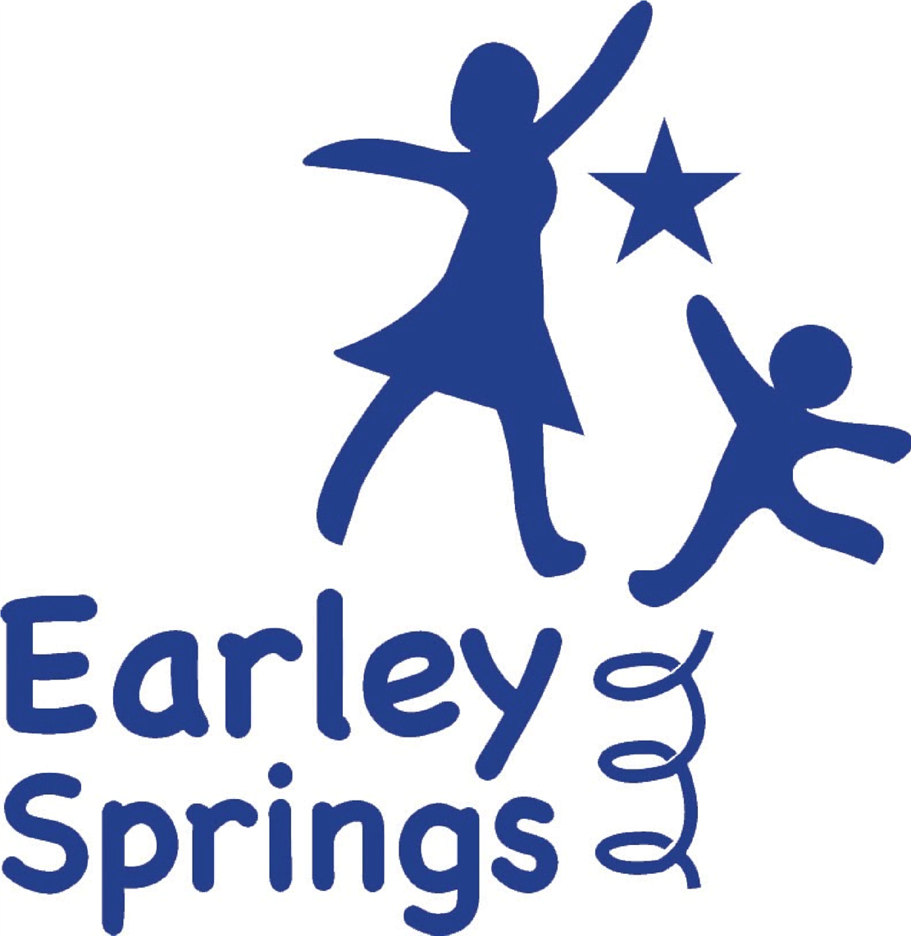

Written by | Harriet Carter | October 2025
Next review due by |  | October 2026

Statement of Intent
Earley Springs School is fully committed to safeguarding and promoting the welfare of all children and young people. We expect every member of staff, volunteer, contractor, and visitor to share this commitment.
Our recruitment practices follow the principles set out in Keeping Children Safe in Education (KCSIE 2025), the Independent School Standards (ISS, Part 4 – Suitability of Staff, Supply Staff, and Proprietors), and all relevant employment legislation.
We recognise that effective safer recruitment is fundamental to protecting pupils. Our procedures are designed to:
- Deter, identify, and reject unsuitable individuals;
- Identify and mitigate potential safeguarding risks;
- Promote equality, fairness, and transparency at every stage of recruitment; and
- Maintain a fully compliant Single Central Record (SCR) evidencing all statutory pre-employment checks.
All appointments are made in the best interests of pupils and with their safety as the highest priority. The Headteacher has operational oversight of recruitment, while the Executive Board retains strategic responsibility for monitoring safer recruitment practice and SCR compliance.

Recruitment Principles
All appointments at Earley Springs are made on merit, following a fair, consistent, and transparent process. Safeguarding is central to every recruitment decision.
The school fully complies with:
- Employment Law and the Equality Act 2010;
- Keeping Children Safe in Education 2025; and
- The Education (Independent School Standards) Regulations 2014 (Part 4).
At least one member of every recruitment panel will have completed Department for Education–approved Safer Recruitment Training. All recruitment decisions are reviewed by the Headteacher and subject to governance scrutiny by the Executive Board, which receives regular updates on safer recruitment and SCR monitoring.

Advertising and Applications
All vacancies are advertised internally and/or externally to attract a diverse pool of candidates. Each advert and application pack includes the school’s safeguarding statement:
“Earley Springs School is committed to safeguarding and promoting the welfare of children and young people and expects all staff and volunteers to share this commitment. All posts are subject to enhanced DBS checks, online searches, and other relevant pre-employment checks.”
Applicants must complete the official Earley Springs Application Form in full — CVs alone will not be accepted.
During shortlisting, the recruitment panel will:
- Scrutinise applications for gaps or anomalies and seek clarification before interview;
- Require shortlisted candidates to complete a self-declaration of criminal history (including spent convictions, cautions, and pending cases);
- Require a Disqualification Declaration under the Childcare Act 2006 (where applicable); and
- Carry out online and social media checks, in line with KCSIE Part 3, to identify any potential safeguarding or reputational concerns.
All information obtained through these checks will be handled confidentially and in accordance with the Rehabilitation of Offenders Act 1974 (Exceptions Order 1975) and the Data Protection Act 2018 / UK GDPR.

Shortlisting and Selection
All shortlisted candidates are invited to interview. The process is designed to assess both professional competence and suitability to work with children, exploring candidates’ values, judgement, and commitment to safeguarding.
Each interview includes:
- A formal panel with at least one Safer Recruitment–trained member;
- Structured questions linked to the job description and person specification;
- Safeguarding and child-protection scenario questions to test understanding and professional boundaries;
- Discussion of employment gaps, reference discrepancies, and safeguarding disclosures; and
- Verification of identity and original documentation (right to work in the UK, qualifications, and professional registrations).
Clear records of the interview process — including scoring and panel notes — are retained securely in accordance with UK GDPR and KCSIE Part 3.
Decisions are made solely on merit, with safeguarding suitability and alignment with the school’s ethos forming core considerations.

Pre-Employment Checks
Before any appointment is confirmed, all statutory pre-employment checks are completed in full compliance with KCSIE 2025 and ISS Part 4, including:
- Enhanced DBS check (with barred list information where appropriate);
- Verification of identity and right to work in the UK;
- Prohibition from Teaching and Section 128 (Management) checks, where applicable;
- Overseas criminal record checks (including certificates of good conduct) where relevant;
- Two satisfactory references, including the most recent employer, verified by direct contact;
- Verification of professional qualifications; and
- Confirmation of medical fitness to carry out the role.
All checks are recorded on the Single Central Record (SCR), maintained by the Headteacher or designated HR Lead. The Executive Board receives termly oversight reports and conducts formal audits to ensure SCR accuracy and safer recruitment compliance.
No employee, volunteer, or contractor may start work until all required checks have been satisfactorily completed and verified.

Allegations Arising During Recruitment or Employment
If, at any stage of recruitment or during employment, an allegation or safeguarding concern arises about a candidate, staff member, or volunteer, the Headteacher (DSL) will immediately refer the matter to the Local Authority Designated Officer (LADO – Kent, 03000 410888).
Where the concern relates to a child in care, the Headteacher will also inform the child’s social worker and the responsible local authority, in line with KCSIE 2025 Part 4.
No appointment will be confirmed — or continued — while an active safeguarding investigation is pending.

Governance Oversight of Safer Recruitment
All recruitment follows KCSIE 2025 Part 3.
The Proprietor, Headteacher, and Executive Board jointly ensure rigorous oversight of safer recruitment and SCR compliance through termly audit, reporting, and review.
The Executive Board’s Safeguarding Link Lead meets regularly with the Headteacher to review recruitment and vetting records and reports findings to the Proprietor for accountability.
This layered approach provides transparent, evidence-based governance oversight and ensures that safeguarding standards remain consistently high.
NB: The Proprietor (Earley Springs Ltd) retains ultimate responsibility for compliance with the Independent School Standards and delegates day-to-day management to the Headteacher, under the oversight of an independent Executive Board.

