Curriculum Policy
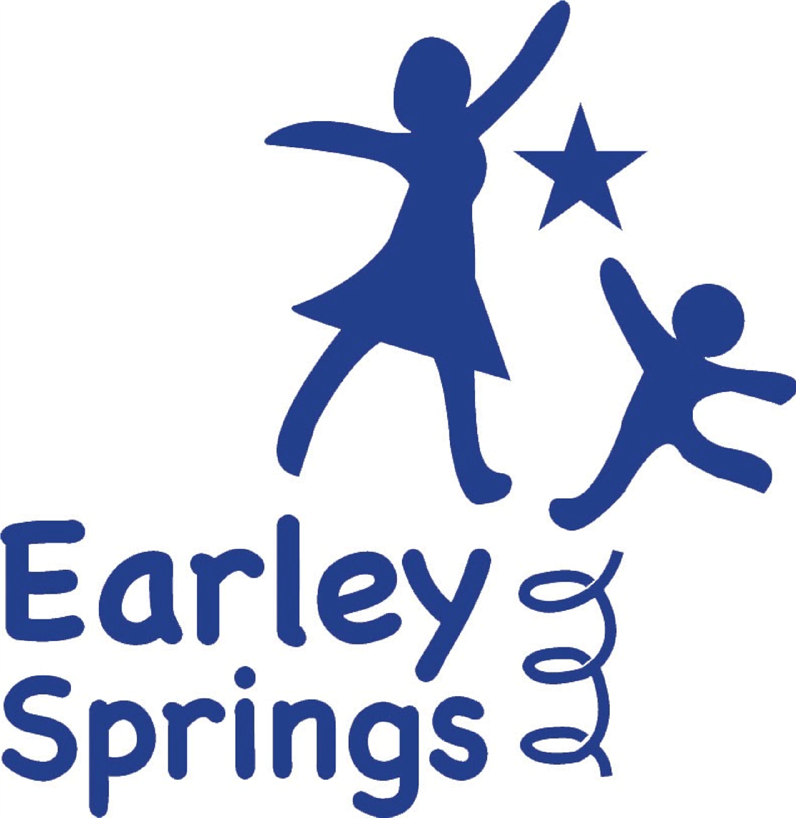

Written by | Harriet Carter | October 2025
Next review due by |  | October 2026

This Curriculum Policy sets out the approach to teaching and learning at Earley Springs School. It reflects our commitment to celebrating every child for who they are, and to providing an education that is meaningful, nurturing and aspirational. All children at Earley Springs are taught according to their ability and developmental stage, rather than their chronological age. This ensures that every pupil is given the opportunity to learn at a pace that is right for them, with learning that is both challenging and supportive.
The curriculum at Earley Springs is designed to enable pupils to make progress socially, emotionally and academically. It is highly personalised and incorporates therapeutic and experiential learning experiences that help children to develop communication, independence and emotional regulation skills. We embed pupils’ Education, Health and Care Plan (EHCP) targets into all planning, ensuring that their learning is purposeful and connected to their individual needs. Our curriculum also prepares pupils for life beyond school, equipping them with real-world skills and confidence for the future.
We deliver our curriculum through three carefully designed pathways: the Explorers, the Discoverers and the Investigators. The Explorers pathway is for children who are working within or just beyond the Early Years Foundation Stage. It draws on Development Matters (2023), the Statutory EYFS Framework (2024) and the Engagement Model (for pupils working below subject-specific learning) to create a sensory-rich environment that focuses on regulation, interaction and early communication. To create a sensory-rich environment that focuses on regulation, interaction and early communication. Learning takes place in calm and predictable spaces, supported by access to our immersive classroom, sensory play areas and opportunities to care for our small animals.
For pupils within the Explorers pathway, provision aligns fully with the Statutory Framework for the Early Years Foundation Stage (EYFS 2024). Assessment follows Development Matters (2023), capturing progress across the prime and specific areas of learning. Observations and developmental tracking inform planning and ensure continuity between Early Years and Key Stage 1 learning. All progress is reviewed termly and linked to pupils’ EHCP outcomes.
The Discoverers pathway is designed for children who are working below subject-specific learning and often follow the Engagement Model. This pathway provides a multi-sensory and highly individualised curriculum that prioritises engagement, interaction and emotional security. Daily routines and structured activities build independence, and pupils access a range of experiences including real-life role-play in our immersive classroom, soft play, and animal-assisted regulation activities. EHCP targets and specialist strategies are central to planning and delivery for this group.
The Investigators pathway is for pupils who are ready to access differentiated elements of the National Curriculum within a therapeutic environment. Learning is structured and aspirational, but delivered at an individualised pace to suit each learner. Social and emotional development is embedded across all subjects, and the pathway includes a strong focus on Preparation for Adulthood. Pupils take part in activities such as budgeting, shopping, travel training and other experiences that help them to develop functional life skills. Regular use of the immersive classroom and sessions with our school dog and small animals provide additional opportunities for emotional regulation and engagement.
Across all pathways at Earley Springs, pupils access an ambitious and broad curriculum aligned with the National Curriculum. Expectations for progress remain high across all subjects, regardless of a pupil’s pathway, age, or developmental stage. This reflects our commitment to early intervention, ensuring pupils develop the skills and confidence to reintegrate into or learn alongside mainstream provision where appropriate.
We recognise that for many children, educational progress is not linear. Development may vary across different areas of learning, and pupils often show strengths in one domain while requiring additional support in another. To reflect this, our curriculum is flexible and responsive: pupils can move fluidly between pathways, or access elements of more than one pathway within their school day, where this supports accelerated progress, engagement and confidence. This ensures that every child experiences learning that is both appropriately challenging and personally meaningful.
Pupils engage in core learning in English, Mathematics and Science, carefully adapted to be accessible, functional and aspirational:
- English includes a systematic, structured phonics and literacy programme, alongside functional reading and writing tasks and communication-focused activities that develop expressive and receptive language.
- Mathematics follows a coherent, mastery-based progression that promotes number fluency, reasoning and problem-solving through real-world, practical contexts.
- Science is taught through exploratory, hands-on investigations that foster curiosity and an understanding of the world around us.
All pupils also experience a broad range of foundation subjects, including History, Geography, Art, Music, Computing, Physical Education and PSHE/RSHE. These subjects are embedded within a range of themed topics that often link to a key text, the seasonal time of year, or a Preparation for Adulthood (PfA) focus. This thematic approach ensures learning feels connected, relevant and immersive, allowing pupils to revisit and deepen understanding across different contexts.
Our learning environment is designed to promote engagement, regulation and readiness for the wider world. Facilities include a fully equipped immersive classroom, soft play and sensory rooms, and spaces for animal-assisted learning. Every class is supported by a consistent staffing model of one qualified teacher and two teaching assistants, with flexibility to increase adult support where required to meet pupils’ needs.
Planning and assessment at Earley Springs are entirely personalised. Lessons are multi-sensory and experiential, providing pupils with meaningful and memorable learning opportunities.
Classroom delivery is highly differentiated. Teachers use a total communication approach, integrating AAC, visuals, signing, and structured supports to make learning accessible for all pupils.
- Phonics, reading and writing is delivered through small-group and 1:1 teaching, with tactile, visual and sensory supports, specifically Read Write Inc.
- Mathematics is taught using manipulatives, concrete materials and visual representations to reinforce understanding, specifically using White Rose Maths (where appropriate).
- Science and topic lessons incorporate sensory exploration, real-life investigations, and cross-curricular links.
All schemes are adapted to reflect pupils’ EHCP targets, sensory profiles and communication systems, ensuring inclusion and personalised progress.
Assessment is carried out using the B Squared tool, complemented by evidence from Development Matters, Engagement Model observations, and differentiated National Curriculum outcomes. Progress is tracked termly and is shared with parents, carers and local authorities as part of our commitment to transparent and collaborative practice.
This assessment approach ensures a clear link between curriculum intent, classroom delivery and pupil outcomes. Evidence from B Squared, Engagement Model observations and teacher assessment is triangulated to track progress accurately. Assessment data informs next steps in teaching, EHCP target review and termly progress reporting to parents and local authorities.
The impact of our curriculum is seen in the personalised progress that our pupils make against their EHCP targets and curriculum outcomes. We see improvements in communication, social interaction and emotional regulation, as well as increased independence and engagement in learning. Our curriculum ensures that pupils leave Earley Springs with the skills, confidence and resilience they need to succeed in the next stage of their education and in life.
The Executive Board and Proprietor hold strategic responsibility for monitoring the effectiveness of the curriculum. Oversight is achieved through termly curriculum reports, lesson observation reviews, and pupil progress data analysis. The Safeguarding and Curriculum Link Governor meets regularly with the Headteacher to evaluate impact, ensuring that the curriculum remains compliant, ambitious and responsive to pupils’ individual needs.

