Careers Education, Information, Advice and Guidance (CEIAG) Policy
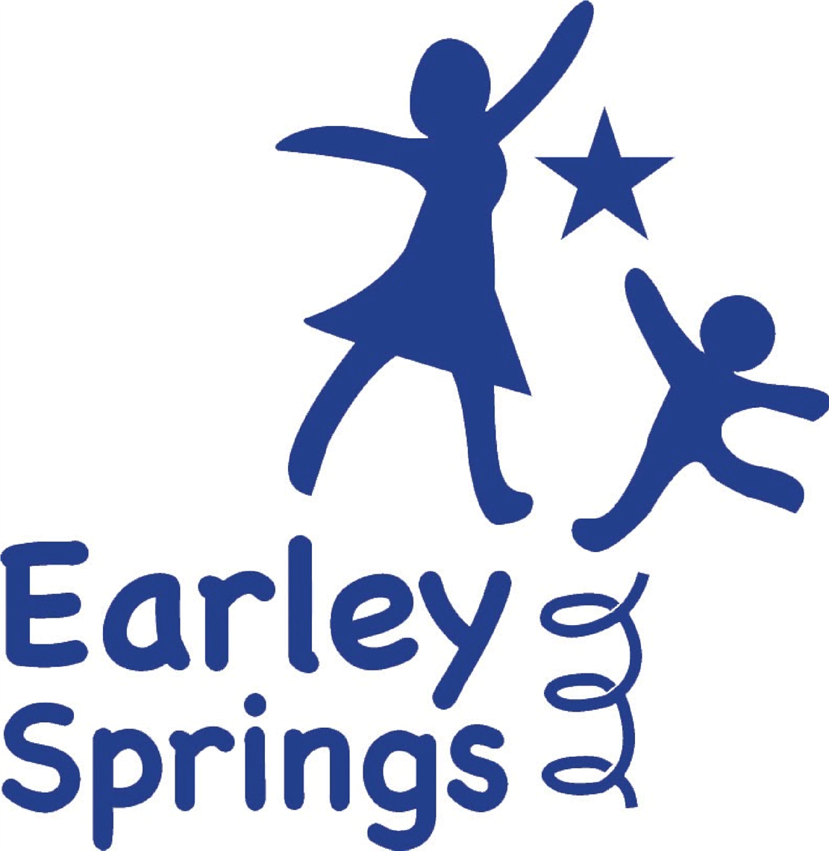

Writen by | Harriet Carter | October 2025
Reviewed on

Introduction
At Earley Springs School, we believe that every child deserves the opportunity to look forward to the future with hope and ambition. Preparing our pupils for adulthood is at the heart of what we do, and our approach to Careers Education, Information, Advice and Guidance (CEIAG) is designed to ensure that every young person—regardless of ability or pathway—has access to meaningful, age-appropriate guidance about learning, training and employment opportunities.
This policy sets out how we meet our responsibilities under Section 42B of the Education Act (1997) and the Independent School Standards. Our programme reflects national guidance and the principles of Preparing for Adulthood (PfA), helping pupils to develop independence, confidence and the skills they need to take their next steps in life.

Student Entitlement
All pupils at Earley Springs have the right to impartial, high-quality careers guidance that helps them to explore who they are, what they enjoy, and what they might want to do in the future. Careers education is not something that happens in isolation; it is woven through our curriculum, our daily routines, and our community links.
Throughout their time at Earley Springs, although more targeted from the age of ten, pupils begin to develop early awareness of work, responsibility and aspiration through practical, hands-on experiences. As they move through the Explorers, Discoverers and Investigators pathways, careers learning becomes more personalised and focused on individual interests, abilities and future goals.
We are committed to ensuring that every pupil—no matter their starting point—has opportunities to explore a range of routes, including further education, training, supported internships and community participation. Our aim is to raise aspirations and remove barriers so that each child can make informed choices about their future.

Provider Access and Engagement
We work closely with a range of education and training providers to ensure pupils understand the options available to them after school. These include local colleges, apprenticeship providers and employers such as East Kent College, Mid Kent College and Kite College.
All requests from external providers are coordinated through the school’s Careers Lead. Sessions are planned carefully to ensure they are accessible, engaging and relevant to the needs of our learners. Events include workshops, presentations, visits and themed days which give pupils the chance to learn about the world of work and further study in a supportive environment.

Delivery and Implementation
Careers education at Earley Springs does not sit as a single subject; instead, it runs through every aspect of school life. It is delivered through life-skills lessons, enterprise projects, community visits, and our thematic Preparing for Adulthood curriculum (that has a key focus for each week regardless of curriculum pathway). Pupils take part in experiences that help them develop independence, communication, teamwork and problem-solving skills.
Senior Leadership Team, Teachers, teaching assistants and external professionals all play a role in delivering and supporting careers learning. Staff receive regular training to ensure that they are confident in helping pupils think about their aspirations and next steps.

Learners with SEND
All pupils at Earley Springs receive careers guidance, including those with significant or complex needs. We believe that every child can have goals for their future, and it is our role to help them discover what those might be and how to get there.
For pupils in the Explorers pathway, this might mean developing an early sense of the world of work through sensory exploration, role play or community visits. Discoverers pupils engage in practical life-skills sessions, communication-based projects and activities that build confidence and independence. Investigators pupils experience work-related learning, vocational sessions, and guidance focused on transition to further education or employment.
This approach ensures that careers education grows with the child, offering the right support at the right time. It also guarantees that every learner, whatever their ability, receives independent and impartial advice that helps them prepare for adulthood.

Assessment and Evaluation
The success of our CEIAG programme is measured through ongoing evaluation, feedback and data analysis. We track pupil participation, progress towards career-related outcomes, and achievement of Gatsby Benchmarks to ensure that our provision remains ambitious and relevant.
Each year, we review destination and qualification data to understand how effectively our curriculum is preparing pupils for the next stage of their lives. This information helps us plan improvements to our CEIAG provision, shape curriculum priorities and build stronger links with local colleges, training providers and employers. For example, if destination data shows an increase in supported employment placements, we use this to strengthen our partnerships with organisations offering these opportunities.
This reflective process ensures that our CEIAG programme evolves in line with pupils’ needs and with local labour market trends.

Learning Outcomes
Our approach follows the Career Development Institute (CDI) framework, which encourages pupils to:
- understand their strengths and interests,
- explore possible pathways,
- make decisions with increasing independence, and
- recognise the value of work and community involvement.
For some pupils, this might mean learning how to travel independently or manage money. For others, it might involve preparing for college interviews or exploring work placements. Whatever the stage, careers education is designed to be relevant, motivating and empowering.

Integration with the Curriculum
Careers learning is built into every area of the curriculum. Pupils develop transferable skills through subjects such as English, Maths, Science and PSHE, while our wider provision—including community visits, enterprise projects and animal-assisted learning—helps them see how what they learn in school connects to the world around them.
Staff use real-life examples and practical experiences to make careers education meaningful. This might involve running a pop-up café, organising a fundraising event, or taking part in local community projects. Through these activities, pupils learn teamwork, communication, problem-solving and resilience—all essential skills for adult life.

Staff Training and Resources
We recognise that high-quality careers education depends on confident, knowledgeable and well-supported staff. All staff at Earley Springs receive ongoing training in CEIAG delivery, including understanding the Gatsby Benchmarks, Preparing for Adulthood outcomes and how to adapt careers learning for pupils with a range of communication, sensory and social needs.
Training takes place through internal CPD sessions, professional discussions, and links with external careers and SEND specialists. Staff are encouraged to share good practice, reflect on their delivery and build strong connections between curriculum learning and real-life experiences.
Our immersive room provides a unique environment for pupils to explore vocational concepts and real-world scenarios in a fully accessible way. For example, pupils can experience virtual work environments such as shops, cafés, travel hubs or care settings, allowing them to rehearse social and practical skills in a calm, supportive space. These sessions often act as a bridge to real community experiences, helping pupils build confidence and independence.
Additional resources include digital CEIAG platforms, college prospectuses, visual communication tools, and community links with local employers and training providers. Careers learning is reinforced through classroom displays, newsletters and parent engagement, ensuring that pupils’ aspirations are celebrated and supported across the whole school.

The Executive Board
The Executive Board is responsible for ensuring that careers education meets statutory expectations and that it continues to improve year on year. Leaders review destination and qualification data annually to evaluate the impact of the CEIAG programme. Findings are shared with the Board and feed into the school’s development planning.
The Executive Board also play a role in supporting new partnerships with employers and providers to ensure that pupils have access to a broad range of experiences that reflect local and national opportunities.

