Assessment Policy

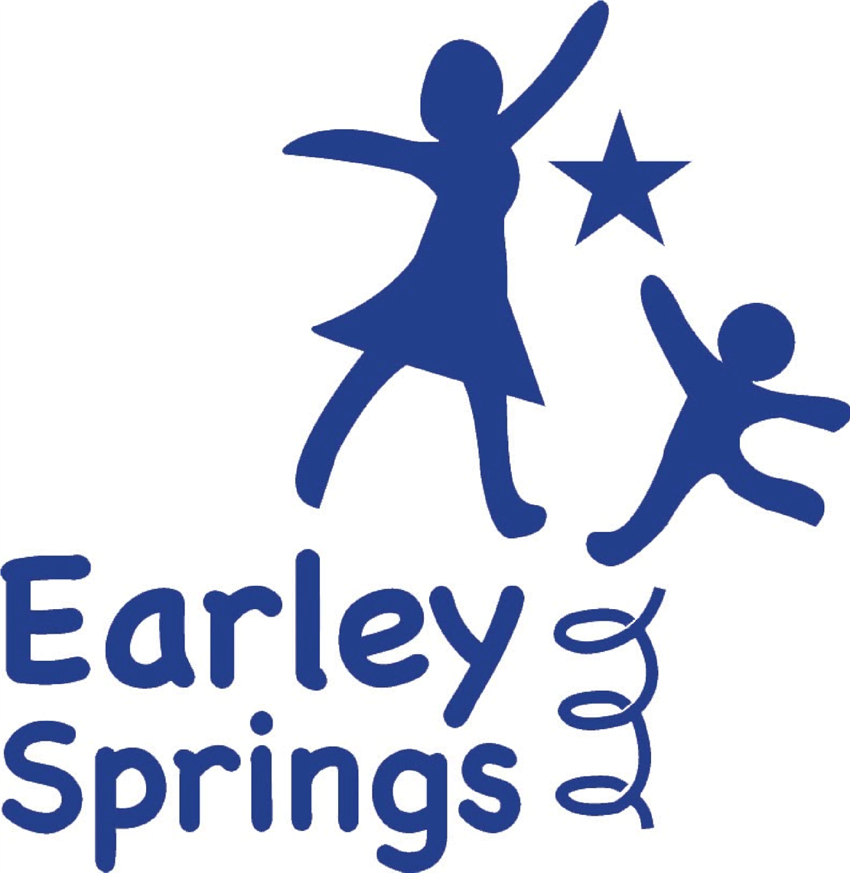

Written by | Harriet Carter | October 2025
Next review due by |  | October 2026

Underpinning Principles for Assessment
Assessment is fundamental to the teaching and learning process at Earley Springs. It provides the evidence that guides our teaching and allows students to demonstrate and review their own progress. We believe that assessment should be fair, inclusive of all abilities, and free from any bias that is not relevant to what is being assessed. Honesty in assessment is paramount. This means that assessment outcomes are used in ways that support learning and minimize any negative consequences. We are open and transparent in how we convey assessment results to students, and our experienced staff moderate judgements to ensure accuracy.
We strive for ambition in our assessment practices. This means setting high expectations for our learners and placing their achievements in context with expected standards. Through objective criteria, assessment embodies a clear pathway of progress and development for every child.
All assessment practices should be appropriate to the age and stage of the learner, as well as the specific task and the type of feedback desired. We believe in using a wide range of evidence to gain a complete picture of student achievement, while keeping our procedures and record-keeping efficient and focused on planning for future learning.
Consistency in assessment is also key. This ensures that judgements are made according to common principles, that results are easily understood by all stakeholders, and that our results can be compared with others.
Meaningful assessment outcomes provide valuable information for everyone involved in the educational process. Students use this information to develop their learning, parents use it to support their children, and teachers use it to plan and improve their teaching. Assessment data also informs decision-making for appropriate agencies, local authorities, school leaders, and governing bodies, as well as government bodies.
Finally, we believe that assessment feedback should inspire greater effort in our students and foster a belief that they can achieve more through hard work and practice.
Our Philosophy of Assessment
At Earley Springs, assessment is an integral part of high-quality teaching and learning. It helps us ensure that our teaching is effective and that learners are making the expected progress. All staff members receive regular training in our assessment approach, and we have a senior leader, currently the headteacher, who oversees assessment practices.
The main purpose of assessment at Earley Springs is to provide information that helps teachers, parents, and students plan their next steps in learning. We also use assessment outcomes to evaluate and enhance our teaching standards. By collaborating with other provisions and utilising external tests and assessments, we can compare our performance with that of other provisions.
Our Assessment System
Earley Springs uses B Squared to record both formative and summative assessment data. This holistic framework allows us to assess students not only against academic standards, but also against the life skills that will help them become better learners and prepare them for their futures.
Our admissions procedures include an assessment period covering literacy, numeracy, reading, and speech and language. This helps us establish a baseline for each student and begin the process of developing a personalised curriculum.
Assessment Across Curriculum Pathways
Assessment at Earley Springs is fully aligned with our three curriculum pathways: Explorers, Discoverers and Investigators.
- Explorers (Early Years & Engagement Model): Assessment follows the Statutory Framework for the Early Years Foundation Stage (2024) and Development Matters (2023), supported by the Engagement Model for pupils working below subject-specific learning. Observations, photos and evidence of play-based learning are captured through B Squared and Evisense to show progress across the prime and specific areas of learning.
- Discoverers: Assessment combines B Squared Connecting Steps with SCERTS and the Engagement Model to track social communication, emotional regulation and functional cognition.
- Investigators: Assessment aligns with the National Curriculum using B Squared to measure attainment and progress, linked to EHCP outcomes and SCERTS targets.
This structure ensures continuity of assessment and a clear progression pathway from Early Years through to Key Stage 3.
Our Approach to Different Forms of Assessment
Formative assessment is an ongoing process that happens during learning. It helps us assess students' knowledge, skills, and understanding; identify their strengths and any gaps in their learning; address misconceptions; and determine the next steps in their learning journey. Formative assessment also helps us diagnose the need for any extra support or intervention, and it informs teacher planning and reporting. We use a variety of formative assessment methods, including questioning, marking, observation, quizzes, reviewing student work, providing feedback, and encouraging self-assessment and reflection.
In-school summative assessment gives us a summary of what a child has learned over a period of time. These assessments, which are carried out at the end of each term, help teachers make informed judgements about student attainment and track progress within specific groups, classes, and across the whole provision. Summative assessments can take the form of written tests, observations, specific tasks, or photographs. We use B Squared to map children's progress against age-related expectations. We also use some summative assessments as diagnostic tools to inform our ongoing teacher assessments. These include White Rose Maths assessments, Codebreakers Phonics assessments and extended writing tasks.
While we prioritise student wellbeing and self-esteem alongside learning, nationally standardised summative assessments are not considered beneficial for our students, who often arrive with gaps in their education. Instead, we focus on individual progress and utilise the Bsquared framework to assess students against the year band 'stage' they are working towards. Our teachers have high expectations and are knowledgeable about the standards expected for their students' ages.
For pupils within the Explorers pathway, assessment is rooted in the EYFS Statutory Framework (2024) and Development Matters (2023). Practitioners gather evidence through observation, play, and adult-led activities to identify progress across the seven areas of learning. Outcomes are moderated termly, recorded in B Squared, and inform transition planning into Key Stage 1. Pupils working below the expected level are assessed using the Engagement Model to capture meaningful small-step progress.
Our Use of Assessment
We ensure our teachers stay up-to-date with the latest developments in assessment practice through regular staff meetings and professional development opportunities. Teachers use assessment data to analyse student attainment and progress, plan future learning, and identify any students who may need extra support. This information is shared with both parents and students, along with guidance on next steps. We celebrate all achievements across a broad and balanced curriculum, art, performance, behaviour, and social and emotional development. Assessment outcomes directly inform curriculum planning and delivery. Teachers use termly assessment analysis to adapt lesson content within each pathway, ensuring curriculum intent, implementation and impact are closely aligned.
Governance, Management, and Evaluation of Assessment
The headteacher, as the designated Assessment Leader, is responsible for ensuring that this policy is implemented effectively. Senior leaders monitor the effectiveness of our assessment practices through various methods, including pupil performance meetings, data analysis, tracking data, and work scrutiny. We also conduct regular moderation to ensure that our assessment judgements are consistent and accurate. The Senior Leadership Team ensures that assessment practice remains consistent with the school’s Curriculum Policy, analysing termly data to evaluate the impact of teaching and curriculum design. Findings from data reviews inform the School Development Plan and are shared with governors and local authorities where appropriate.
Roles and Responsibilities
All members of the Earley Springs community have a role to play in assessment. The Executive Board monitors whole-school data and practices, the Senior Leadership Team leads moderation and analysis, teachers implement assessment daily, and support staff contribute observational feedback. Parents engage in progress meetings, and pupils are encouraged to take ownership of their learning.

